Monitoring / On-Call Approval Form

Employee Name: Nikunj Adhaduk _

Manager Name: Yaser Shadmehr .
Monitoring Hours
Date of Monitoring (mm/dd/yyyy) | Project | Reason | Number of Hours
TOTAL

On-Call Payment
Dates On-Call (mm/dd/yyyy – mm/dd/yyyy) | # of Weeks | Rate
9/1/2024 – 9/7/2024 | 1 | 200
9/15/2024 – 9/21/2024 | 1 | 200
9/22/2024 – 9/28/2024 | 1 | 200
9/29/2024 – 10/5/2024 | 1 | 200
TOTAL |  | 800
Approvals
Employee Signature: 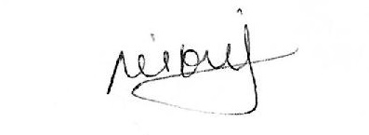 | Date:  Oct 7, 2024
Manager Signature: | Date:  Oct 7, 2024

Please submit to Payroll once approved.

Description
Date of Monitoring | Hours | Reason
Sept 4, 2024 | 1.5 | Streaming Logic App after hours Deployment and disabling of data lake pipeline support
Sept 18, 2024 | 2 | Had to execute the cosmos query group by documenttype and this is related to check the impact cause by using the same consumergrip by DE team in eventhub. And due to none partition query and have minimal impact had to run all of those 2 AM with range of a week
Sept 23, 2024 | 1.5 | Answering and Helping ITOPS pager on no data receveing in data lake alert and analysis and support to team to finding the breaking point and restarting the job to get the data start going to datalake to resume BNS streaming
Oct 2, 2024 | 0.75 | SEON deployment after hours support
Oct 4, 2024 | 2 | CINEPLEX DDOS attack supporting DE team on analysis and closing down all effected endpoints

